**Employee Management System**

**Introduction:**

Employee Management System is based on a concept to store and generate all the records of the employees. This program is considered as a simple database of employees in an office, an organization where the user can store employees record easily as it is not time-consuming.

**Features:**

1. Add Record
2. Search Record
3. Edit Record
4. Modify Record
5. Display Record
6. Salary Record
7. Display Salary Record

**Objectives:**

 This project aims to simplify the task of maintaining records of the employees of Company. To develop a well-designed database to store employee information. The objective of this project is to provide a comprehensive approach towards the management of employee information.

**Purpose:**

Employee Management System is a distributed application, developed to maintain the details of employees working in any organization. The EMS has been developed to override the problems prevailing in the practicing manual system. It maintains the information about the personal and official details of the employees.

**C++ Concepts:**

The concepts that we have used in this project are

1. Queues
2. Linked List
3. File Handling
4. Classes
5. Structures
6. Conditional statements
7. Loops
8. Constructors

**Advantages:**

* Provide computerized system for maintaining records.
* More efficient & reliable.
* Less time consuming and easy to use.
* Huge data storage with less computer memory.
* Avoid Human errors & efforts for Maintaining daily data.
* Avoid Data manipulations.
* Also avoids Data inconsistency & redundancy.

**Limitations:**

* This software will run on a single pc
* Admin and Employee have to sit on the same pc
* No network connection
* No GUI (Graphical User Interface)

**CODE:**

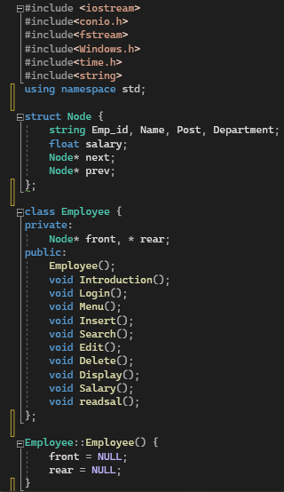

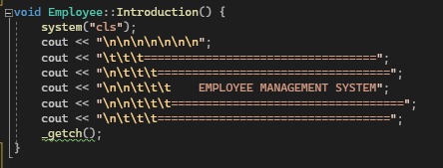

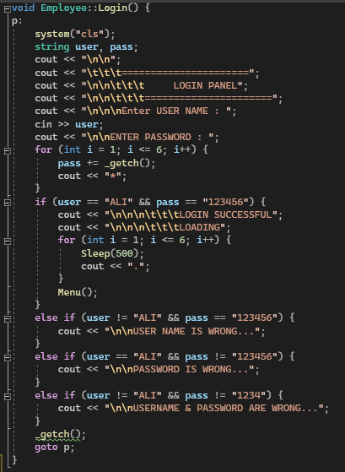

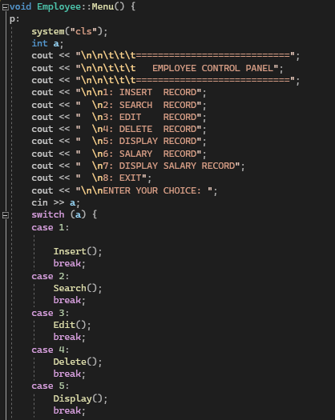

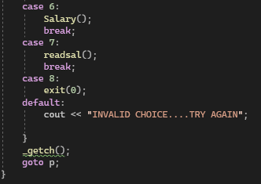

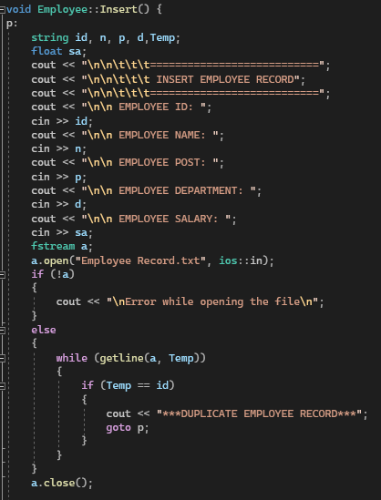

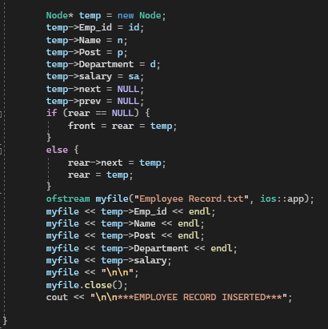

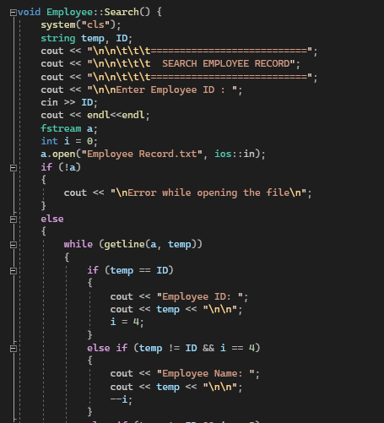

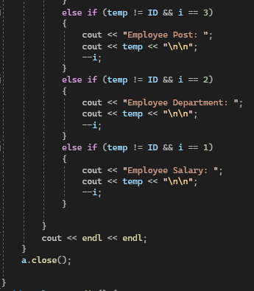

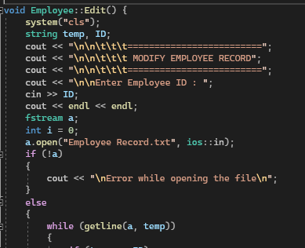

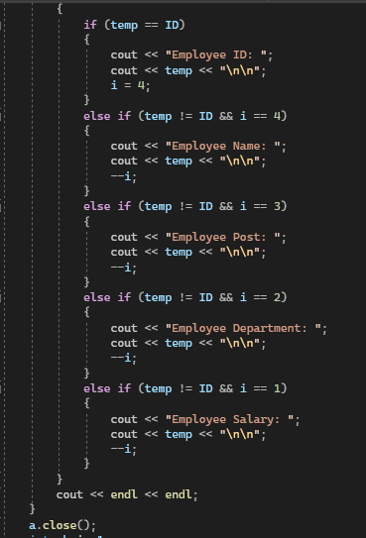

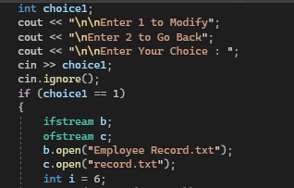

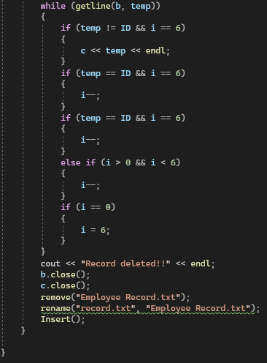

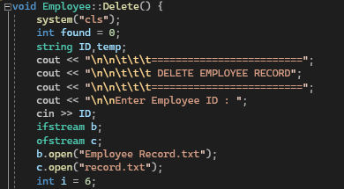

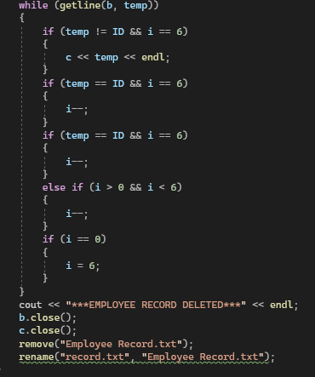

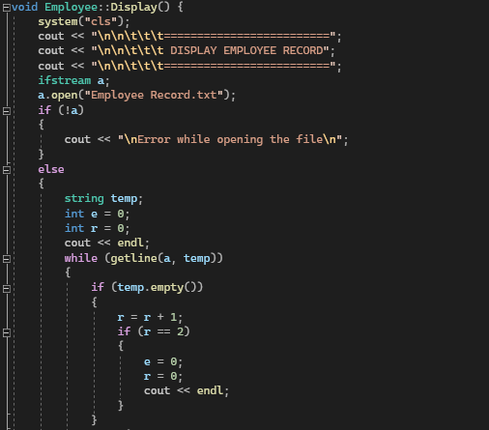

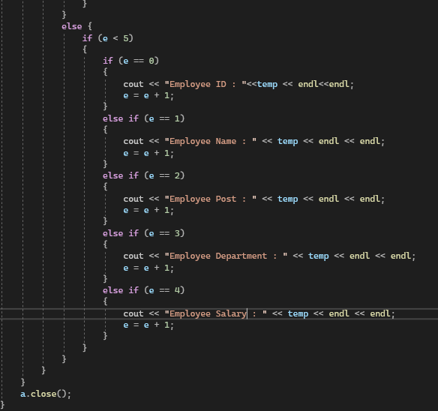

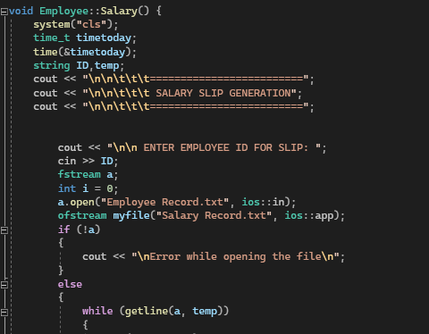

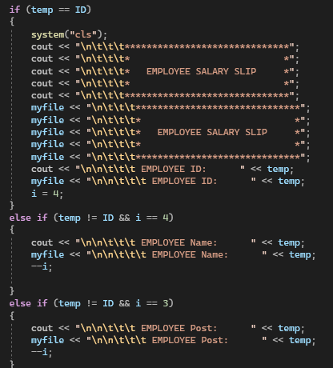

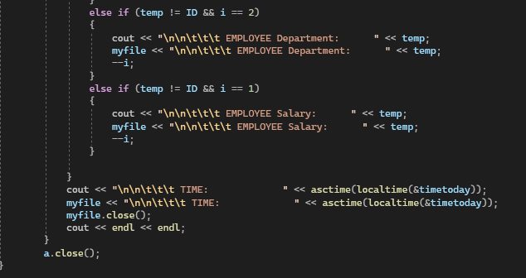

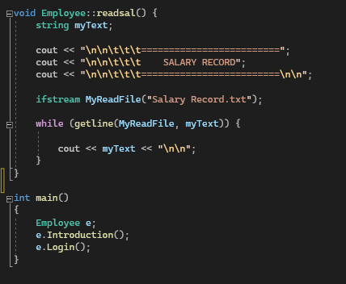

**OUTPUTS**

**1: Introduction**

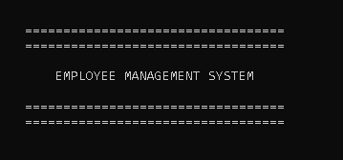

**2: Login Panel**

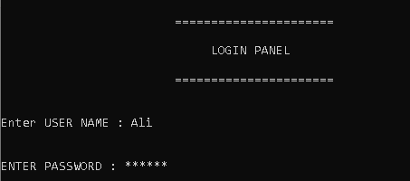

**3: Control Panel**

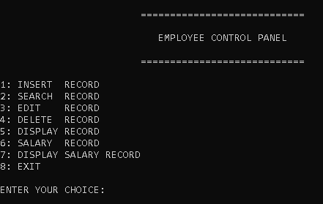

**4: Insert Record**

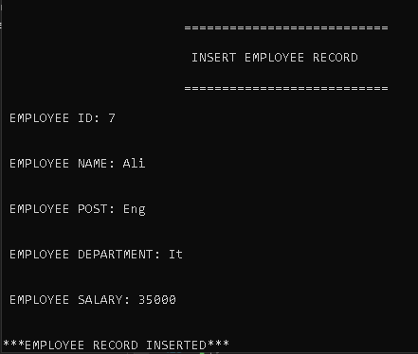

**5: Search Record**

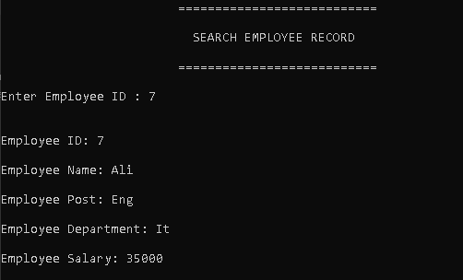

**6: Delete Record**

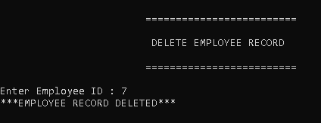

**7: Edit Record**

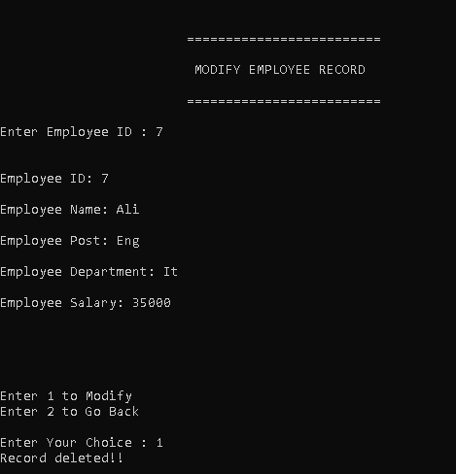

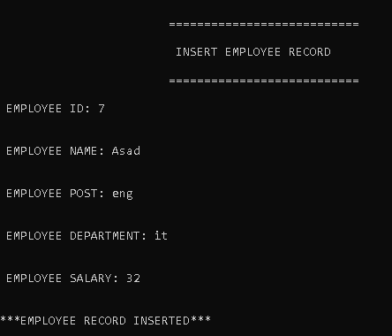

**8: Display Record**

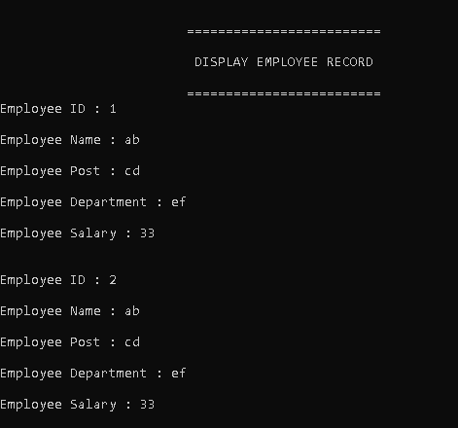

**9: Salary Record**

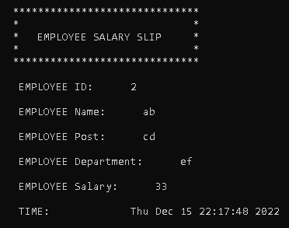

**10: Display Salary Record**

